Chapter 5, Problem 14

Determine the output voltage v_{o} in the circuit of Fig. 5.53.
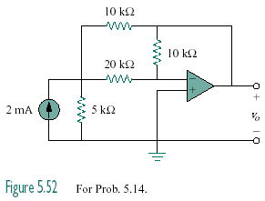

Figure 5.53
For Prob. 5.14.

